**Q1.**

**A company has an API to manage purchase orders, with each record identified by a unique purchase order ID. The API was built with RAML according to MuleSoft best practices.**

**What URI should a web client use to request order P05555?**

A/orders/{P05555}

B/orders/order=P05555

C/orders?order=P05555

D/orders/P05555

ANSWER: A

**Q2.**

**A Database On Table Row listener retrieves data from a CUSTOMER table that contains a primary key userjd column and an increasing kxjin_date_time column. Neither column allows duplicate values.**

**How should the listener be configured so it retrieves each row at most one time?**

ASet the watermark column to the bgin_date_time column

BSet the target value to the last retrieved login_date_time value

CSet the target value to the last retrieved user_jd value

DSet the watermark column to the user_Id column

ANSWER: B

**Q3.**

**Refer to the exhibits.**

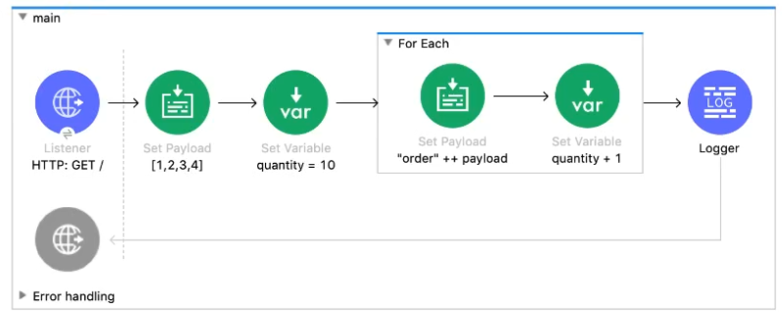

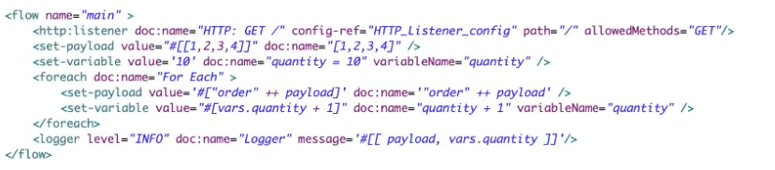

**What payload and quantity are logged at the end of the main flow?**

A[[1,2,3,4], 14]

B[[order1, order2, order3, order4], 14]

C[[1,2,3,4], 10]

D[orderlorder2order3order4,14]

ANSWER: B

**Q4.**

**A Mule project contains a DataWeave module called MyModule.dwl that defines a function named formatString. The module is located in the project's src/main/resources/modules folder.**

**What is the correct way in DataWeave code to import MyModule using a wildcard and then call the module's formatString function?**

**A)**

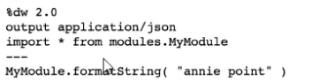

**B)**

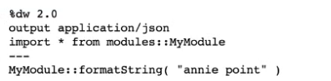

**C)**

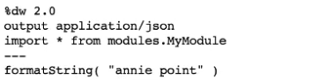

**D)**

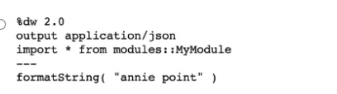

AOption A

BOption B

COption C

DOption D

ANSWER: C

**Q5.**

**Refer to the exhibits.**

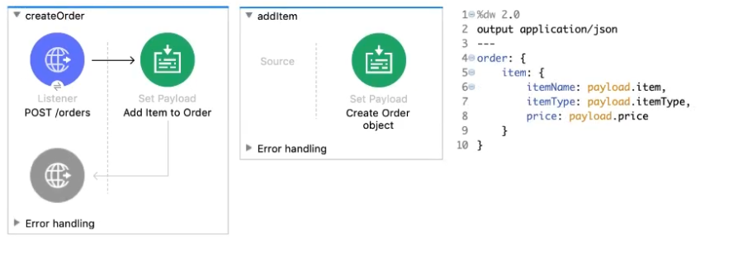

**The Set Payload transformer In the addltemsubflow uses DataWeave to create an order object.**

**What is the correct DataWeave code for the Set Payload transformer in the createOrder flow to use the addltemsubflow to add a router cable with the price of 100 to the order?**

Aaddltemf{ payload: { price: '100', item: 'router', itemType: 'cable' } > )

Blookupf 'addltem', { payload: { price: '100', item: 'router', itemType: 'cable' } } )

Caddltemf{ price: '100', item: 'router', itemType: 'cable' })

Dlookupf 'addltem', { price: '100', item: 'router', itemType: 'cable' } )

ANSWER:B

What condition requires using a CloudHub Dedicated Load Balancer?

**A**When cross-region load balancing is required between separate deployments of the same Mule application

**B**When custom DNS names are required for API implementations deployed to customer-hosted Mule runtimes

**C**When API invocations across multiple CloudHub workers must be load balanced

**D**When server-side load-balanced TLS mutual authentication is required between API implementations and API clients

ANSWER:B

Question 2

When designing an upstream API and its implementation, the development team has been advised to not set timeouts when invoking downstream API. Because the downstream API has no SLA that can be relied upon. This is the only donwstream API dependency of that upstream API. Assume the downstream API runs uninterrupted without crashing. What is the impact of this advice?

**A**The invocation of the downstream API will run to completion without timing out.

**B**An SLA for the upstream API CANNOT be provided.

**C**A default timeout of 500 ms will automatically be applied by the Mule runtime in which the upstream API implementation executes.

**D**A load-dependent timeout of less than 1000 ms will be applied by the Mule runtime in which the downstream API implementation executes.

ANSWER:C

Question 3

An API has been updated in Anypoint Exchange by its API producer from version 3.1.1 to 3.2.0 following accepted semantic versioning practices and the changes have been communicated via the API's public portal. The API endpoint does NOT change in the new version. How should the developer of an API client respond to this change?

**A**The update should be identified as a project risk and full regression testing of the functionality that uses this API should be run.

**B**The API producer should be contacted to understand the change to existing functionality.

**C**The API producer should be requested to run the old version in parallel with the new one.

**D**The API client code ONLY needs to be changed if it needs to take advantage of new features.

ANSWER:D

Question 4

A new upstream API Is being designed to offer an SLA of 500 ms median and 800 ms maximum (99th percentile) response time. The corresponding API implementation needs to sequentially invoke 3 downstream APIs of very similar complexity. The first of these downstream APIs offers the following SLA for its response time: median: 100 ms, 80th percentile: 500 ms, 95th percentile: 1000 ms. If possible, how can a timeout be set in the upstream API for the invocation of the first downstream API to meet the new upstream API's desired SLA?

**A**Set a timeout of 100 ms; that leaves 400 ms for the other two downstream APIs to complete

**B**Do not set a timeout; the Invocation of this API Is mandatory and so we must wait until it responds

**C**Set a timeout of 50 ms; this times out more invocations of that API but gives additional room for retries

**D**No timeout is possible to meet the upstream API's desired SLA; a different SLA must be negotiated with the first downstream API or invoke an alternative API

ANSWER:D

Question 5

An organization has several APIs that accept JSON data over HTTP POST. The APIs are all publicly available and are associated with several mobile applications and web applications. The organization does NOT want to use any authentication or compliance policies for these APIs, but at the same time, is worried that some bad actor could send payloads that could somehow compromise the applications or servers running the API implementations. What out-of-the-box Anypoint Platform policy can address exposure to this threat?

**A**Apply a Header injection and removal policy that detects the malicious data before it is used

**B**Apply an IP blacklist policy to all APIs; the blacklist will Include all bad actors

**C**Shut out bad actors by using HTTPS mutual authentication for all API invocations

**D**Apply a JSON threat protection policy to all APIs to detect potential threat vectors

ANSWER:B

Question 6

An organization is implementing a Quote of the Day API that caches today's quote. What scenario can use the CloudHub Object Store connector to persist the cache's state?

**A**When there is one deployment of the API implementation to CloudHub and another one to customer hosted mule runtime that must share the cache state.

**B**When there are two CloudHub deployments of the API implementation by two Anypoint Platform business groups to the same CloudHub region that must share the cache state.

**C**When there is one CloudHub deployment of the API implementation to three workers that must share the cache state.

**D**When there are three CloudHub deployments of the API implementation to three separate CloudHub regions that must share the cache state.

ANSWER:A

Question 7

An organization is evaluating using the CloudHub shared Load Balancer (SLB) vs creating a CloudHub dedicated load balancer (DLB). They are evaluating how this choice affects the various types of certificates used by CloudHub deployed Mule applications, including MuleSoft-provided, customer-provided, or Mule application-provided certificates. What type of restrictions exist on the types of certificates for the service that can be exposed by the CloudHub Shared Load Balancer (SLB) to external web clients over the public internet?

**A**Underlying Mule applications need to implement own certificates

**B**OnlyMuleSoft provided certificates can be used for server side certificate

**C**Onlyself signed certificates can be used

**D**All certificates which can be used in shared load balancer need to get approved by raising support ticket

ANSWER:B

Top of Form

Refer to the exhibit. What are the values of the counter and stepVar variables in the On Complete phase?

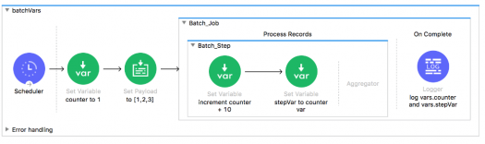



Counter: 31, stepVar: 31



Counter: 1, stepVar: 31



Counter: 31, stepVar: null



Counter: 1, stepVar: null

ANSWER:C

Bottom of Form

Top of Form

What MuleSoft product enables publishing, sharing, and searching of APIs?



API Designer



API MUnit



Anypoint Exchange



API Notebook

ANSWER:C

Bottom of Form

Top of Form

Refer to the exhibit. What are the values of the counter and stepVar variables after the Batch Job?

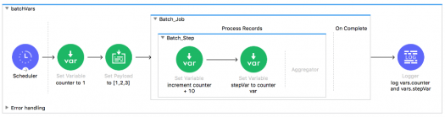



Counter: 31, stepVar: 31



Counter: 1, stepVar: 31



Counter: 1, stepVar: null



Counter: 31, stepVar: null

ANSWER:D

Bottom of Form

Top of Form

A Batch Job scope has three batch steps. An event processor in the second batch step throws an error because the input data is incomplete. What is the default behavior of the batch job after the error is thrown?



Event processing continues to the third batch step



All processing of the batch job stops



The second batch step is retried



The first batch step is retried

ANSWER:B

Bottom of Form

Top of Form

Refer to the exhibits. What is the output of the Logger component in the Batch Job?

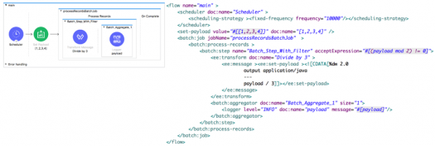



[.333]  
[1]



[.333, 1]



[.333, .667, 1, 1.333]



[.333]  
[.667]  
[1]  
[1.333]

Bottom of Form

Top of Form

In a RAML specification, what attribute defines a query parameter to be optional for a resource?



Required: false



Optional: true



Provided: false



Mandatory false

ANSWER:A

Bottom of Form

Top of Form

What is NOT part of a Mule 3 message?



Payload



InboundProperties



OutbountProperties



Variables



Attachments

ANSWER:C

Bottom of Form

Top of Form

What out-of-the-box policy can safeguard against Denial of Service type attacks?



Rate limiting



Throttling



Cross-origin resource sharing



LDAP security manager

ANSWER:A

Bottom of Form

Top of Form

A Mule application properties file named training-DEVproperties has been defined. How is the properties file referenced in the Mule application?



In an attribute in the main mule element



In a Property Placeholder element



As a -M-D placeholder when starting the Mule runtime



In an attribute in the HTTP Listener element

ANSWER:D

Bottom of Form

Top of Form

What port number is used to expose the domain URL of a Mule application deployed to CloudHub?



8081



81



80



8080

ANSWER:A

Bottom of Form

Top of Form

What message processor can set the HTTP response status code to 200?



Variable



Set Payload



Property



Record Variable



Attachment

ANSWER:B

Bottom of Form

Top of Form

What property of a Mule message is immutable?



Attachments



OutboundProperties



Session Variables



Payload



InboundProperties



Flow Variables

ANSWER:E

Bottom of Form

Top of Form

A Mule application has two flows named parentFlow and childFlow. A variable is defined in parentFlow. What is true for a Mule subflow?



It can have its own exception strategy



It is executed synchronously



An external client can send messages directly to it



It must be in the same configuration file as the parent flow

ANSWER:A

Bottom of Form

Top of Form

What is the default processing strategy of a one-way flow?



Queued-asynchronous



Synchronous



Non-blocking



Thread-per-processor



Queued-thread-per-processor

ANSWER:A

Bottom of Form

Top of Form

What is required for two Mule applications to share data using a VM connector component?



Put the Mule applications in the same Anypoint Platform environment



Put the Mule applications in the same Anypoint Platform business group



Put the Mule applications in the same non-default Mule domain



Put the Mule applications in the same default Mule domain

ANSWER:B

Bottom of Form

Top of Form

How are outbound properties automatically passed to an outbound REST request using an HTTP Request component?



As headers



As query parameters



As URI parameters



In the message payload



As attachments



As flow variables

ANSWER:B

Bottom of Form

Top of Form

A WSDL defines a conversionRate operation with an input message that requires two parts: fromCurrency and toCurrency. How are fromCurrency and toCurrency set in the flow in order to call the conversionRate operation using a Web Service Consumer component?



In two flow variables



As outbound properties



As inbound properties



In the message payload



As attachments

ANSWER:C

Bottom of Form

Top of Form

What is NOT a way to pass data to a RESTful web service in a flow using an outbound HTTP Request component?



Set URI parameters in the HTTP Request component



Set inbound properties before the HTTP Request component



Set query parameters in the HTTP Request component



Set outbound properties before the HTTP Request component

ANSWER: B

Bottom of Form

Top of Form

What asset can NOT be created using Anypoint Platform Design Center?



API Specifications



Mule Applications



API Fragments



API portals

ANSWER:C

Bottom of Form

Top of Form

An exception is caught by a choice exception strategy. How is the exception routed?



To all exceptions whose conditions evaluate to true



To the first exception strategy whose condition evaluates to true



To the first exception strategy whose condition evaluates to true and to the default exception strategy



To the first exception strategy whose condition evaluates to true and to the global exception strategy

ANSWER:C

Bottom of Form

Top of Form

How is a default exception strategy set in a Mule application?



In a configuration global element in any Mule configuration XML file



In the mule-app.properties file



As an attribute of one or more flow configuration elements in one or more Mule configuration XML files



As an attribute of a global exception strategy



As a JVM system environment variable

ANSWER:B

Bottom of Form

Top of Form

A Payload filter is configured to test for type javalang_String. What happens when the filter is passed a message with the payload null?



The Mule application stops



The message is replayed from the start of the flow



The message is passed to subsequent message processors



All subsequent message processors are skipped

ANSWER:D

Bottom of Form

Top of Form

What module and operation will throw an exception if a Mule event's payload is not a number?



Validation module’s Is number operation



Validation module’s Is not number operation



Filter’s module’s Is number operation



Filter’s module’s Is not number operation

ANSWER:A

Bottom of Form

Top of Form

A Mule flow has a JMS queue listener as the message source. Where can the next message processor access a JMS messages header?



Outbound property



Inbound property



Payload



Attachment



Flow variable

ANSWER:D

Bottom of Form

Top of Form

What part of a Mule flow can contain a Poll scope?



Async scope



Message source



For Each scope



Message Enricher scope

ANSWER:D

Bottom of Form

Top of Form

How is a Poll scope's watermark accessed from a message processor in a flow?



In a session variable



In an outbound property



In an inbound property



In a flow variable



In a header

ANSWER:D

Bottom of Form

Top of Form

A File connector configured to read files from a /mule/input directory. All other File connector settings are the default settings. What happens to a file after it is processed by the File connector?



The file is moved to /mule/output



The file is deleted from the input directory, but is not moved anywhere



The file is moved to /tmp



The file stays in the input directory

ANSWER:B

Bottom of Form

Top of Form

What phase of a batch job using a Batch scope must contain at least one message processor?



Input



Load and Dispatch



Process Records



On Complete

ANSWER:D

Bottom of Form

Top of Form

A message payload is modified using a Message Enricher scope with an empty target. What is true about the message payload that leaves the Message Enricher scope?



The payload is changed to the modified payload



The modified payload is stored in a flow variable



The modified payload is stored as an inbound property



The payload returns to the original payload



The modified payload is stored as an outbound property

ANSWER:D

Bottom of Form

Top of Form

A Batch scope has three batch steps. A message processor in the second batch step throws an exception because the input data is incomplete. What is the default behavior after the exception is thrown?



Continues to the third batch step



Stops processing the entire batch job



Retries the second batch step



Retries the first batch step

ANSWER:A

Bottom of Form

Top of Form

What is the purpose of the api:router element in APIkit?



Routes requests to API implementations, but does not validate them against RAML API specifications



Routes responses to the caller, but does not validate them against RAML API specifications



Validates requests against RAML API specifications and routes them to API implementations



Validates responses returned from API requests and routes them to the caller

ANSWER:A

Bottom of Form

Top of Form

What is the scope of a record variable in a Batch scope?



In a single batch step, but not in the other batch steps



In all batch steps, but not in the On Complete phase



In the message source, each batch step, and the On Complete phase



In all batch steps, and the On Complete phase

ANSWER:B

Bottom of Form

Top of Form

A web client submits a GET request to a Mule 4 application to the endpoint /customers?id=48493. Where is the id stored in the Mule event by the HTTP Listener?



Inbound properties



Variables



Attributes



Payload

Bottom of Form

Top of Form

Assume that a database table contains a record ID column that always increases as new records get added to the table. In a Mule application, what is the key process to enable manual watermarking for requests to a database using the Scheduler endpoint and the Database SELECT operation?



Save the max recordID from the set of recordIDs in an ObjectStore and reference this record in subsequent database requests



Enable automatic watermarking in the Database SELECT operation



Set the Watermark column in the Scheduler endpoint to the recordID



Save the max recordID from the set of recordIDs in a variable and reference this variable in subsequent database request

Bottom of Form

Top of Form

How is the success of a Center for enablement measured?



Measured on policies in place



Measured on asset consumption



Measured on accessibility of assets



Measured on number of assets available

Bottom of Form

Top of Form

1. What are four ways APIs provide the info for how to communicate with a software component? (Select 4... lol)



Operations (what to call)



Inputs (what to send with a call)



Outputs (what you get back from a call)



Underlying data types

Bottom of Form

Submit My Answer

Top of Form

This defines what you can call, what you send it, and what you get back:



API Specification



API Proxy



Web Service

Bottom of Form

Top of Form

An API has been created in Design Center. What is the next step to make the API discoverable?



Deploy the API to a Maven repository



Enable autodiscovery in API Manager



Publish the API from inside flow designert



Publish the API to Anypoint Exchange

Bottom of Form

Top of Form

What is an application that controls access to a web service, restricting access and usage with an API gateway?



API Specification



API Proxy



Web Service

Bottom of Form

Top of Form

What is the actual implementation you can make calls to or the interface of that API implementation?



API Specification



API Proxy



Web Service

Bottom of Form

Top of Form

How are SOAP web services defined?



In an XML-based WSDL (Web Services Description Language) file



DUH

Bottom of Form

Top of Form

In what file does the Mule project keep track of all of its dependencies?



Mule-artifact.json



Pom.xml



Mule-app.properties



Global.xml

Bottom of Form

Top of Form

What do RESTful web services use?



Existing HTTP communication protocol



DUH

Bottom of Form

Top of Form

What is the minimum required configuration in a flow for a Mule application to compile?



An event processor/A message processor in the Process section of a flow



An event/message processor in the Source section of a flow



An empty flow



A message processor in both the Source and Process sections of a flow

Bottom of Form

Top of Form

What can ONLY be done with VM connectors, and NOT with Flow References, in a single Mule application?



Preserve variables as the Mule event gets passed to another flow



Allow a flow to pass events to another flow synchronously



Preserve the original payload when the VM connector returns a response from a flow



Allow a flow to pass events to another flow asynchronously

Bottom of Form

Top of Form

Which RESTful web service request method partially updates a resource?



GET



POST



DELETE



PUT



PATCH

Bottom of Form

Top of Form

Which RESTful web service request method creates a new resource?



GET



POST



DELETE



PUT



PATCH

Bottom of Form

Top of Form

An inbound Database connector is configured to select rows from a MySQL database. What is the format of results returned from the database query?



Java



JSON



XML



CSV

Bottom of Form

Top of Form

Which RESTful web service request method deletes a resource?



GET



POST



DELETE



PUT



PATCH

Bottom of Form

Top of Form

What is NOT part of a Mule 4 event?



Message



Payload



InboundProperties



Attributes

Bottom of Form

Top of Form

What file type is required to configure a Web Service Consumer to consume a SOAP web service?



RAML



WSDL



JSON



OAS

Bottom of Form

Top of Form

How does APIkit determine the number of flows to generate from a RAML specification?



Creates a separate flow for each HTTP method



Creates a separate flow for each resource



Creates a separate flow for each resource that contains child resources



Creates one flow for the entire API spec



Creates a separate flow for each response status code

Bottom of Form

Top of Form

How are query parameters dynamically passed to an outbound REST request using an HTTP Request operation?



As query parameters in the HTTP Request operation



As URI parameters in the HTTP Request operation



In the Mule’s event’s payload



As flow variables



As attributes in a Transform Message component before the HTTP Request operation



As attributes in the HTTP Listener operation

Bottom of Form

Top of Form

What is the purpose of API autodiscovery?



Enables API Manager to discover the published API on Anypoint Exchange



Allows the Mule application to be automatically discovered on Anypoint Exchange



Enables the API to be directly manage in API Manager



Allows a deployed Mule application to connect with API Manager to download policies and act as its own API proxy

Bottom of Form

Top of Form

1. Refer to the exhibit:

*#%RAML 1.0 title: ACME Medical API baseUri: https://dev.acme.com/api* */patients:* *GET:* *queryParameters: year: type: integer* *example: 2017* What is the correct URL to perform a GET request to /patients?



Http://dev.acme.com/patients?year=2016



Http://dev.acme.com/api/patients



Http://dev.acme.com/patients



Http://dev.acme.com/api/patients?year=2016

Bottom of Form

Top of Form

Refer to the exhibit. The flow calls a SOAP endpoint using the Consume operation of the Web Service Consumer. The SOAP service has a required input parameter. What event processor can be used to build the SOAP envelope with the required argument to pass to the SOAP service?

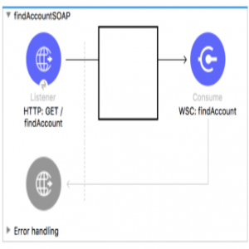



Set Property



Build SOAP



Transform Message



JSON to XML



Set Attachment

Bottom of Form

Top of Form

Which RESTful web service request method retrieves the current state of a resource in some representation (usually JSON or XML)



GET



POST



DELETE



PUT



PATCH

Bottom of Form

Top of Form

Which RESTful web service request method replaces a resource completely? (If the resources doesn't exist a new one is created)



GET



POST



DELETE



PUT



PATCH

Bottom of Form

Top of Form

A RAML example fragment named BankAccountsExample.raml is placed in the examples folder in an API specification project. What is the correct syntax to reference the fragment?



Example: !include BankAccountsExample.raml



Example: #import BankAccountsExample.raml



Example: !include examples/BankAccountsExample.raml



Example: #import examples/BankAccountsExample.raml

Bottom of Form

Top of Form

What are four benefits of API portals? (Choose 4)



Documentation and examples



Way to register applications and get access to the API



Way to provide feedback and make requests



Way to test the API by making calls to it

Bottom of Form

Submit My Answer

Top of Form

What is the maximum number of Mule applications that can run in a Cloud Hub Worker?



At most one



At least one



Depends on the vCores



Depends on the number of CloudHub workers configured

Bottom of Form

Top of Form

What takes data and devices connected with APIs to make them pluggable and to create reusable services?



Application network



DUH

Bottom of Form

Top of Form

What is a method of communication that allows two software systems to exchange data over the internet?



Web Service



DUH

Bottom of Form

Top of Form

What does an API proxy application NOT do?



Determine which request Mule event is allowed to pass through to the API backend service



Apply runtime policies to enforce governance



Determine which response Mule event is allowed to pass through to the API backend service



Measure the traffic flowing through the proxy

Bottom of Form

Top of Form

An HTTP Request operation returns a JSON array of objects. In the Transform Message component, what is the process to convert the array of objects to an array of custom Java Account objects?



Add the Account object metadata to the output and use the drag-and-drop feature to transform the incoming JSON data



Change the output type to the Java Account object type



Add the Account object metadata to the input and the Transform Message component will automatically convert the JSON objects to Account objects



Change the input type to the Java Account object type

Bottom of Form

Top of Form

What provides info for how to communicate with a software component?



API



DUH

Bottom of Form

Top of Form

What do RESTful web services use?



Standard HTTP protocol



DUH

Bottom of Form

Top of Form

When a REST API is added to the exchange, what is automatically created for it?



API Portal



DUH

Bottom of Form

Top of Form

What are three things an API portal has? (Choose 3)



Auto-generated API documentation



API console



Auto-generated API endpoint that uses a mocking service

Bottom of Form

Submit My Answer

Top of Form

Refer to the exhibit: *1 #%RAML 1.0* *2 title: American Flights API* *3 version: 10* *4* *5 /flights: 6 get:* *7 8 /{flight_id}:* *9 10 get:* There is an error in the flight_id resource's GET method. What needs to be done to fix the problem?



Remove blank line on row 9



Enclose flight_id with parenthesis () instead of curly braces {}



Indent the get method under the {flight_id} resource



Outdent the {flight_id} resource



Remove the curly braces {} around flight_id

Bottom of Form

Top of Form

What is the process to create a connector using REST Connect?



Develop the API in flow designer and publish the API to Exchange



Design the API in Anypoint Studio and upload the API to Runtime Manager



Design the API In Design Center and publish the API to Exchange



Develop the API in Anypoint Studio and export the connector as a jar file

Bottom of Form

Top of Form

When is a connector automatically created?



When a RAML 1.0 API specification is added to the exchange



DUH

Bottom of Form

Top of Form

What application is used for building integration apps that connect systems and consume APIs?



API designer



Anypoint Studio



Flow Designer

Bottom of Form

Top of Form

How are multiple conditions used in a Choice router to route events?



To find the FIRST true condition, then route the same event to the matched route and ALL FOLLOWING routes



To route the same event to the matched route of EVERY true condition



To find the FIRST true condition, then distribute the event to the ONE matched route



To filter and aggregate the responses after copying the event to EVERY route

Bottom of Form

Top of Form

Refer to the exhibit. This RAML specification includes an XML example that matches the Records data type defined in another RAML file named recordsDataType.raml. Using the Records type, how can this XML example be represented in RAML?

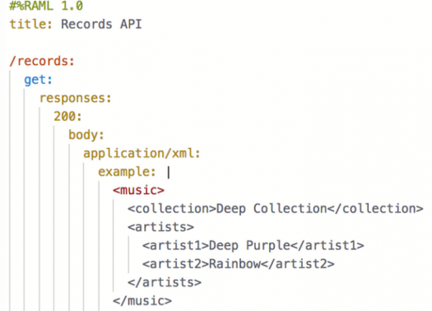



Option 1

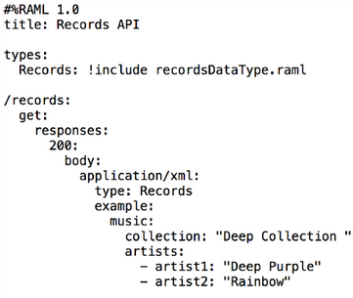



Option 2

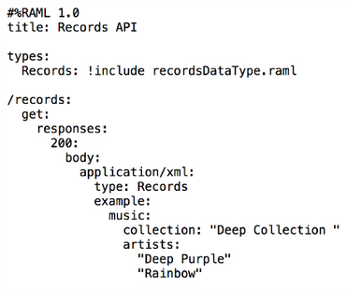



Option 3

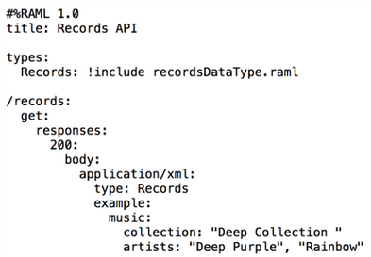



Option 4

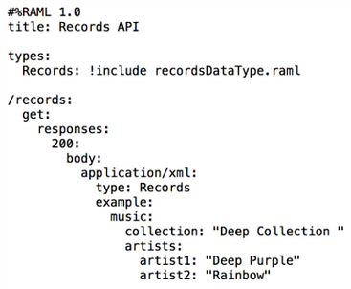

Bottom of Form

Top of Form

What application is used for implementing APIs and building integration applications?



Anypoint Studio



API designer



Flow Designer

Bottom of Form

Top of Form

What application is used for designing, documenting, and mocking APIs?



Flow Designer



API designer



Anypoint Studio

Bottom of Form

Top of Form

What is the language Mule uses to access, query, and transform event data?



DataWeave 2.0



DUH

Bottom of Form

Top of Form

What does the Mule runtime use to enforce policies and limit access to APIs?



Anypoint Access Control



The proxy created by API Manager



API Manager



The Mule runtime’s embedded API Gateway

Bottom of Form

Top of Form

API Manager has been configured to enforce an SLA policy and the RAML spec has been updated with the required client_id and client_secret header requirements. The new RAML spec has been published to Anypoint Exchange. What is the next step to gain access to the API?



POST a JSON object to the /api/register endpoint of the API proxy



Request access to the API in Anypoint Exchange



Email the organization administrators to request access to the API



Add a client application to the Anypoint Platform organization

Bottom of Form

Top of Form

What happens to the attributes of a Mule event in a flow after an outbound HTTP Request is made?



New attributes may be added from the HTTP response headers, but no headers are ever removed



New attributes may be added from the HTTP response, but previous attributes are passed through unchanged



Attributes do not change



Attributes are replaced with new attributes from the HTTP Request response (which might be null)

Bottom of Form

Top of Form

A Scatter-Gather processes three separate HTTP requests. Each request returns a Mule event with a JSON payload. What is the final output of the Scatter-Gather?



An Object containing all three Mule event Objects



An array of three JSON payload Objects



An array of the three Mule event Objects



An Object containing all three JSON payload Objects



The last JSON payload Object



The last Mule event object

Bottom of Form

Top of Form

An event contains a payload that is an array of Objects. How is the event routed in a Scatter-Gather?



The ENTIRE event is sent to each route and processed SEQUENTIALLY



The event is SPLIT and different SMALLER events are routed and processed in PARALLEL



The event is SPLIT and different SMALLER events are routed and processed SEQUENTIALLY



The ENTIRE event is sent to each route and processed in PARALLEL

Bottom of Form

Top of Form

A Set Variable component saves the current payload to a variable with the name images. What is the DataWeave expression to access the images variable?



#[payload.images]



#[images]



#[flowVars.images]



#[vars.images] (vars is a DataWeave predefined variable)

Bottom of Form

Top of Form

What module and operation will throw an error if a Mule event's payload is not a number?



Validation module's Is number operation



Validation module's Is not number operation



Filter module's Is number operation



Filter module's Is not number operation

Bottom of Form

Top of Form

A web service implements an API to handle requests to https://acme.com/customers/{state}. A web client makes a request to this API implementation at https://acme.com/customers/CA. What is the correct DataWeave expression to retrieve the value CA?



#[message.payload.inboundProperties.'http.query.params’.state]



#[message.inboundProperties.'http.uri.params'.state]



#[attributes.uriParams.state]



#[attributes.’http.uri.params’.state]



#[state]

Bottom of Form

Top of Form

Refer to the exhibits. What happens to this flow when the Validation module's Is not null operation throws an error?

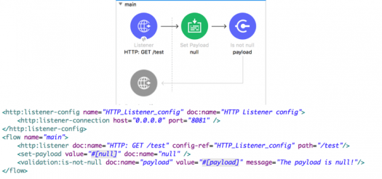



The flow silently stops processing its Mule event



The flow stops processing its Mule event and returns an error message to the HTTP Listener operation



The flow logs the error message in the console and continues processing its Mule event



The flow continues processing its Mule event and appends the error message to the end of the payload

Bottom of Form

Top of Form

A flow contains an HTTP Listener as the event source. What is the DataWeave expression to log the Content-Type header using a Logger component?



#[“Content-Type: “ ++ attributes.headers.’content-type’]



#[“Content-Type: “ + headers.’content-type’]



#[“Content-Type: “ + attributes.headers.’content-type’]



#[“Content-Type: “ ++ headers.’content-type’]

Bottom of Form

Top of Form

Refer to the exhibit. What is the correct DataWeave expression for accessing the city Cleveland from the JSON payload?

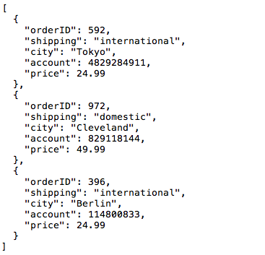



#[payload[2].city]



#[payload[1].city]



#[payload.city[1]]



#[payload.city[2]]

Bottom of Form

Top of Form

What is NOT part of a Mule 4 event?



Message



OutboundProperties



Attributes



Variables



Payload

Bottom of Form

Top of Form

Refer to the exhibits. The main flow has an On Error Continue scope. In the Configuration global element, default error handler is set to globalErrorHandler. A web client makes an HTTP GET request to the flow's HTTP Listener. The Is number validator then throws an error with message "Validate - Payload is an Integer". What response message is returned to the web client?

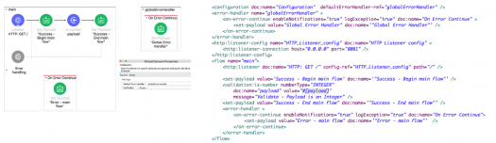



Error - main flow



Success - Begin main flow



Success - End main flow



Validate - Payload is an Integer



Global Error Handler

Bottom of Form

Top of Form

A Mule application has two flows named parentFlow and childFlow. The childFlow begins with an HTTP Listener. A variable is defined in parentFlow, then an HTTP Request is made to childFlow's HTTP Listener with some headers set. What is the scope of the variable and attributes in the parentFlow after childFlow returns a response?



The variable is accessible. All the attributes passed to childFlow are removed or replaced



The variable is NOT accessible. All the attributes passed to childFlow are removed or replaced



The variable is NOT accessible. All the attributes passed to childFlow are preserved



The variable is accessible. All the attributes passed to childFlow are preserved

Bottom of Form

Top of Form

Refer to the exhibits. The main flow has an On Error Propagate scope. In the Configuration global element, default error handler is set to globalErrorHandler. A web client makes an HTTP GET request to the flow's HTTP Listener. The Is number validator then throws an error with message "Validate - Payload is an Integer". What response message is returned to the web client?

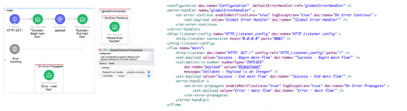



Error - main flow



Success - Begin main flow



Success - End main flow



Validate - Payload is an Integer



Global Error Handler

Bottom of Form

Top of Form

A Mule application has a flow named parentFlow. The parentFlow contains an HTTP Request operation at the end of the flow. The parentFlow also contains a Set Variable operation right before the HTTP Request operation. What is the scope of the variable to the server receiving the HTTP Request from parentFlow?



The variable is accessible in the server but is immutable



The variable is accessible in the server, can be changed, and changes are see back in parentFlow



The variable is NOT accessible in the server



The variable is accessible in the server, can be changed but changes are not seen back in parentFlow

Bottom of Form

Top of Form

A Mule application has two flows named parentFlow and childFlow. A variable is defined in parentFlow. What is the scope of the variable when the parentFlow calls childFlow using a Flow Reference?



The flow variable is accessible in childFlow but is immutable



The flow variable is accessible in childFlow, can be changed, and changes are seen back in parentFlow



The flow variable is NOT accessible in childFlow



The flow variable is accessible in childFlow, can be changed, but changes are NOT seen back in parentFlow

Bottom of Form

Top of Form

Refer to the exhibits. The private flow has an On Error Propagate scope. In the Configuration global element, default error handler is set to globalErrorHandler. A web client makes an HTTP GET request to the flow's HTTP Listener. The Is number validator in the private flow then throws an error with message "Validate - Payload is an Integer". What response message is returned to the web client?

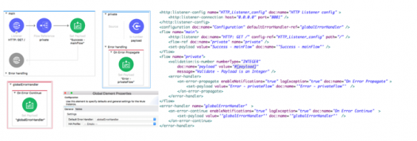



GlobalErrorHandler



Success - mainFlow



Error - privateFlow



Validate - Payload is a Number

Bottom of Form

Top of Form

Refer to the exhibits. The main flow has an On Error Continue scope and the private flow has an On Error Propagate scope. A web client makes an HTTP GET request to the HTTP Listener. The Is number validator in the private flow then throws an error with message "Validate - Payload is an Integer". What response message is returned to the web client?

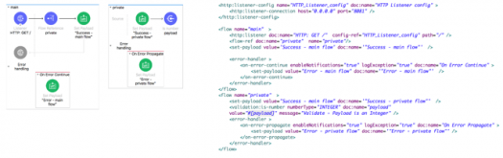



Error - main flow



Success - main flow



Error - private flow



Success - private flow



Validate - Payload is Integer

Bottom of Form

Top of Form

How can an error scope be configured to catch all errors in the HTTP namespace?



Type: HTTP  
When:



Type: HTTP*  
When:



Type:  
When: #[ error.errorType.namespace == "HTTP" ]



Type:  
When: #[ contains "HTTP" ]

Bottom of Form

Top of Form

Refer to the exhibits. The main flow has an On Error Continue scope with type set to HTTP:NOT_FOUND. The Mule application configures globalErrorHandler as its default error handler. A web client posts a request to the HTTP Listener. The Transform Message component then throws a MULE:EXPRESSION error trying to convert the payload to application/xml. What response message is returned to the web client?

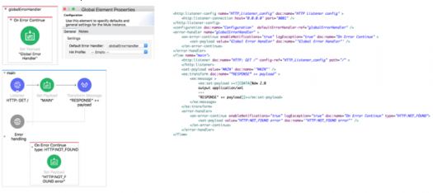



"HTTP:NOT_FOUND error"



"MAIN"



"Global Error Handler"



The MULE:EXPRESSION error's message

Bottom of Form

Top of Form

What MuleSoft API-led connectivity layer is intended to expose part of a backend database without business logic?



Experience



Data



System



Process



Security

Bottom of Form

Top of Form

Refer to the exhibit. An event payload contains an unordered array of flight objects, where every object has a price key and a toAirport key. What is valid DataWeave code to return flights with price under 500, grouped by toAirport in ascending order, with the lowest price first?

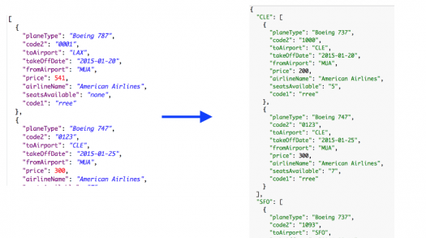



Payload groupBy $.toAirport filter $.price < 500 orderBy $.price



Payload groupBy $.toAirport filter $.price > 500 orderBy $.price



Payload filter $.price < 500 orderBy $.price groupBy $.toAirport



Payload filter $.price > 500 orderBy $.price groupBy $.toAirport

Bottom of Form

Top of Form

Refer to the exhibit. What is valid DataWeave code to transform the input JSON payload to the output XML payload?

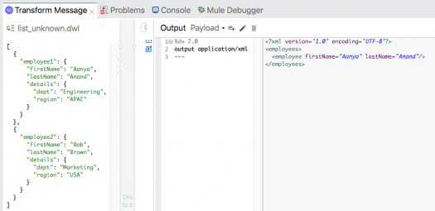



Option 1

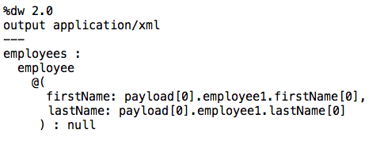



Option 2

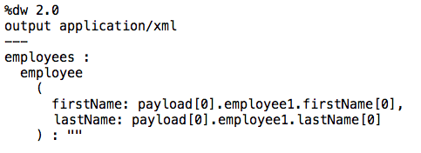



Option 3

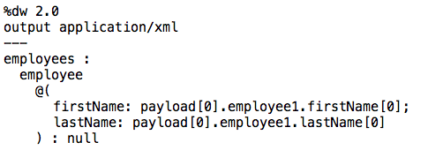



Option 4

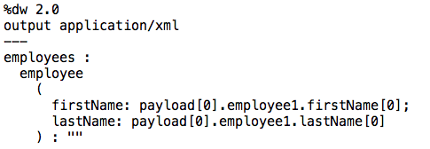

Bottom of Form

Top of Form

Refer to the exhibit. In the deployable archive's /classes folder, there are two properties files named dev.properties and prod.properties. The Mule application fails to deploy to CloudHub through Runtime Manager with the following error message. What could be causing this error?

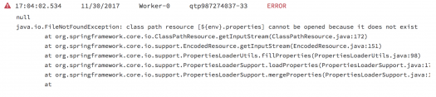



The property files were NOT saved at the root level of the deployable archive



The env property is NOT set in the Runtime Manager in the Mule application's Properties tab



A file named ${env}.properties is NOT included in the deployable archive file



The dev.properties and prod.properties files were NOT uploaded to Runtime Manager

Bottom of Form

Top of Form

A Mule application has a main flow and a combineNames flow. In the main flow, a variable named fullName is set to the object {firstName: "Max", lastName: "Mule"}. What is valid DataWeave code to call the combineNames flow with the input object stored in the fullName variable?



#[ dw::Flow::lookup( "combineNames", vars.fullName ) ]



#[ dw::Runtime::lookup( "combineNames", vars.fullName ) ]



#[ lookup( "combineNames", vars.fullName ) ]



#[combineNames( vars.fullName ) ]



#[ lookup( combineNames( vars.fullName ) ) ]

Bottom of Form

Top of Form

What DataWeave 2.0 type can be used as input to a map operation?



Array



Object



Map



String



Key

Bottom of Form

Top of Form

What is the correct way to format the decimal 20.3844 as a string to two decimal places?



20.3844 as String {format: ".0#"}



20.3844 as :string {format: ".0#"}



20.3844 as String as format: ".0#"



20.3844 as :string as format: ".0#"



20.3844 as String (format = ".0#")



20.3844 as :string (format = ".0#")

Bottom of Form

Top of Form

What reserved property can be defined and used in a Mule application to allow an HTTPS Listener to be accessed by external web clients after the Mule application is deployed to CloudHub?



${ssl.port}



${ssl.listener.port}



${https.listener.port}



${https.port}

Bottom of Form

Top of Form

A Flow Reference component sends a non-empty JSON object payload to another flow named childFlow, which then returns an XML body. A Flow Reference component saves the payload returned from childFlow to its target attribute named payload. Refer to the exhibit. What is true about the Mule event's payload at the next event processor after the Flow Reference component?

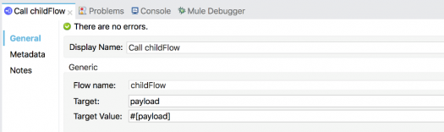



The payload is the XML response body



The payload is a non-empty Java object



The payload is the original JSON object



The payload is null

Bottom of Form

Top of Form

Why must a Mule application's deployable archive package all its dependencies in order to be deployed to CloudHub?



The online logging service requires access to ALL project dependencies to log the appropriate Java classes used in the Mile application



CloudHub workers CANNOT download ALL possible project dependencies a project may contain



CloudHub workers need to compare the current dependencies with the LATEST project dependencies from the Mulesoft repository



Mulesoft support requires access to ALL project dependencies for future online troubleshooting

Bottom of Form

Top of Form

Refer to the exhibit. What is the object type returned by the File List operation?

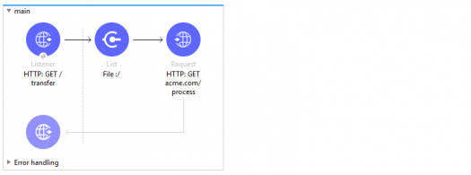



Array of Mule event objects



Object of Mule event objects



Array of String file names



Object of String file names

Bottom of Form

Top of Form

What HTTP method in a RESTful web service is typically used to replace a resource completely?



PATCH



PUT



POST



GET

Bottom of Form

Top of Form

What statement is part of Mulesoft's description of an application network?



Create reusable APIs and assets designed to be consumed by other business units



Creates and manages availability and fault tolerant services and infrastructure



Leverages Central IT to deliver complete point-to-point solutions with master data management



Creates and manages a collection of JMS messaging services and infrastructure

Bottom of Form

Top of Form

According to MuleSoft, what is the Center for Enablement's role in the new IT operating model?



Creates and manages assets to be consumed by of business developers



Centrally manages partners and consultants to implement line of business projects



Implements line of business projects to enforce common security requirements



Produces & manages API policies for line of business deployments

Bottom of Form

Top of Form

What is a core characteristic of the Modern API?



API is designed first using an API specification for rapid feedback



API is rapidly prototyped following AGILE methodology



API follows the RESTful architecture



API has a mechanism to accept feedback and suggestions for improvement

Bottom of Form

Top of Form

In the Database On Table Row operation, what does the Watermark column enable the On Table Row operation to do?



To save the most recent records retrieved from a database to enable database caching



To avoid duplicate processing of records in a database



To enable multithreaded event processing for each record retrieved from a database



To save the payload into the ObjectStore for future reference

Bottom of Form

Top of Form

Refer to the exhibit. *ENDPOINT:* *https://www.searchworld.org/s/api.php QUERY PARAMETERS:* *action - Action type - required* *options: compare, delete, save, search* *query - Search string - required* *profile - Search profile to use* *options: strict, normal, classic* *format - The format of the output* *options: xml, xmlfm, json, jsonfm* *namespace - Namespace to search* *options: 1,2,3,4* *HEADERS:* *AUTH - Authentication token - required* The API specification supports searching for articles on the searchworld.org site. What is the most idiomatic (used for its intended purpose) URL and method to retrieve articles about "einstein" in XML format?



GET Method  
api.php?action=search&query=einstein&format=xml  
AUTH



GET Methodapi.php?&query=einstein&format=xmlAUTH



GET Method  
api.php?action=search&query=einstein&format=xml  
NO AUTH



POST Methodapi.php?action=search&query=einstein&format=xmlAUTH

Bottom of Form

Top of Form

Assume that a database table contains a recordID column that always increases as new records get added to the table. In a Mule application, what is the key process to enable manual watermarking for requests to a database using the Scheduler endpoint and the Database SELECT operation?



Save the max recordID from the set of recordIDs in an Object



Store and reference this recordID in subsequent database requests



Enable automatic watermarking in the Database Select operation



Set the Watermark column in the Scheduler endpoint to the recordID



Save the max recordID from the set of recordIDs in a variable and reference this variable in subsequent database requests

Bottom of Form

Top of Form

What is the main purpose of flow designer in Design Center?



Design API RAML files in a graphical way



To design and Develop fully functional Mule applications in a hosted development environment



Define API lifecycle management in a graphical way



Design and mock Mule application templates that must be implemented using Anypoint Studio

Bottom of Form

Top of Form

A flow has a JMS Publish consume operation followed by a JMS Publish operation. Both of these operations have the default configurations. Which operation is asynchronous (does not wait for a response before continuing to the next event processor) and which operation is synchronous (blocks and waits for a response or timeout before continuing to the next event processor)?



Publish consume: Asynchronous. Publish: Synchronous



Publish consume: Asynchronous. Publish: Asynchronous



Publish consume: Synchronous. Publish: Asynchronous



Publish consume: Synchronous. Publish: Synchronous

Bottom of Form

Top of Form

Where does a deployed flow designer application run in Anypoint Platform?



Exchange



Clouhhub Worker



API Manager



Design Center

Bottom of Form

Top of Form

Refer to the exhibits. The Set Payload component sets the payload to a Map object (not an Array). The File Write operation writes out files based on this Map object. How many files are written to the file system when the flow executes?

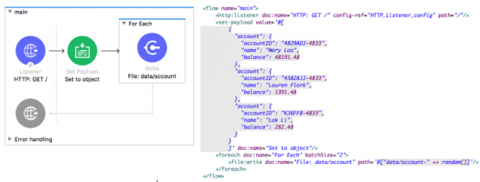



0



1



2



3

Bottom of Form

Top of Form

Refer to the exhibit. The payload [1,2,3] is passed to the Batch Job scope. In Batch_Step_1, a variable named batchStepPayload is set to the current payload. What is the value of the last log message after one batch job completes?

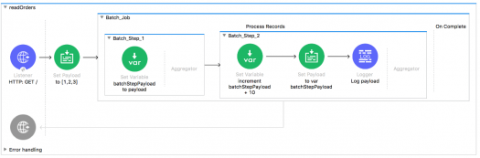



13



[11, 12. 13]



33



30



10

Bottom of Form